Local Grievance # ________

**Issue Statement (Block 15 of PS Form 8190):**

1. Did management violate Article 16.7 of the National Agreement when they placed Letter Carrier **[name]** on Emergency Placement in Off Duty Status without just cause on **[date]** for [**INSERT ALLEGATION**]? If so, what is the appropriate remedy?

**Union Facts and Contentions (Block 17 of PS Form 8190):**

**Facts:**

1. Letter Carrier **[name]** was placed on Emergency Placement on **[date]** for [**INSERT REASON**].
2. Letter Carrier **[name]** has over **[number of years]** years of faithful service with the Postal Service and there was no history of discipline shown in the Emergency Placement notice.
3. The Emergency Placement was based solely on events that took place at **[time of day]** on **[date]**.
4. Management placed the grievant on Emergency Placement at **[time of day]** on **[date]**.
5. Management’s only charge is that the grievant [**INSERT CHARGE**] while on duty on **[date]**.
6. The grievant was provided with written notice on [**INSERT DATE**].
7. Article 16.7 of the National Agreement states in relevant part:

*“An employee may be immediately placed on an off-duty status (without pay) by the employer, but remain on the rolls where the allegation involves intoxication (use of drugs or alcohol), pilferage, or failure to observe safety rules and regulations, or in cases where retaining the employee on duty may result in damage to U.S. Postal Service property, loss of mail or funds, or where the employee may be injurious to self or others…”*

1. National Arbitrator Mittenthal, in case H4N-3U-C 58637, wrote in part:

*When the "emergency procedure" in Section 7 is properly invoked, the employee is "immediately" placed on non-duty, non-pay status. He does not have a right to remain, for any period of time, "on the job or on the clock at the option of the Employer." He suffers an instant loss of pay.* [Emphasis added]

1. National Arbitrator Mittenthal, in case H4N-3U-C 58637, opined:

*The critical factor, in my opinion, is that Management was given the right to place an employee “immediately" on non-duty, non-pay status on the basis of certain happenings. An "immediate . .." action is one that occurs instantly, without any lapse of time.* [Emphasis added]

1. JCAM page 16-8 reads in applicable part:

***Written Notice.*** *Management is not required to provide advance written notice prior to taking such emergency action.* ***However, an employee placed on emergency off-duty status is entitled to written charges within a reasonable period of time****. In H4N-3U-C 58637, August 3, 1990 (C-10146), National Arbitrator Mittenthal wrote as follows:* [Emphasis added]

1. National Arbitrator Mittenthal, in case H4N-3U-C 58637, discussed the written notice requirement under Article 16.7:

*The fact that no "advance written notice" is required does not mean that Management has no notice obligation whatever. The employee suspended pursuant to Section 7 has a right to grieve his suspension. He cannot effectively grieve unless he is formally made aware of the charge against him, the reason why Management has invoked Section 7. He surely is entitled to such notice within a reasonable period of time following the date of his displacement. To deny him such notice is to deny him his right under the grievance procedure to mount a credible challenge against Management ' s action. Indeed, Section 7 speaks of the employee remaining on non-duty, non-pay status "until disposition of the case has been had." That " disposition" could hardly be possible without formal notice to the employee so that he has an opportunity to tell Management his side of the story.* ***Fundamental fairness requires no less.***

1. The following language appears in Article 16 of the Joint Contract Administration Manual (JCAM):

***What Test Must Management Satisfy?*** *Usually employees are placed on emergency non-duty status for alleged misconduct. However, the provisions of this section are broad enough to allow management to invoke the emergency procedures in situations that do not involve misconduct— for example if an employee does not recognize that he or she is having an adverse reaction to medication. The test that management must satisfy to justify actions taken under this Article 16.7 depends upon the nature of the “emergency.” In H4N-3U-C 58637, August 3, 1990 (C-10146)*

*National Arbitrator Mittenthal wrote as follows: My response to this disagreement depends, in large part, upon how the Section 7 “emergency” action is characterized. If that action is discipline for alleged misconduct, then Management is subject to a “just cause” test. To quote from Section 1, “No employee may be disciplined...except for just cause.” If, on the other hand, that action is not prompted by misconduct and hence is not discipline, the “just cause” standard is not applicable. Management then need only show “reasonable cause” (or “reasonable belief”) a test which is easier to satisfy.* [Emphasis added]

1. JCAM Page 16-1 supplies in relative part:

*The principle that any discipline must be for “just cause” establishes a standard that must apply to any discipline or discharge of an employee. Simply put, the “just cause” provision requires a fair and provable justification for discipline.*

1. *JCAM page 16-3 relays in part:*

***Examples of Behavior.*** *Article 16.1 states several examples of misconduct which may constitute just cause for discipline. Some managers have mistakenly believed that because these behaviors are specifically listed in the contract, any discipline of employees for such behaviors is automatically for just cause. The parties agree these behaviors are intended as examples only. Management must still meet the requisite burden of proof, e.g., prove that the behavior took place, that it was intentional, that the degree of discipline imposed was corrective rather than punitive, and so forth. Principles of just cause apply to these specific examples of misconduct as well as to any other conduct for which management issues discipline.* [Emphasis added]

1. The following language appears in Article 16 of the Joint Contract Administration Manual (JCAM), page 16-9 provides in part:

***Section 8. Review of Discipline***

*In no case may a supervisor impose suspension or discharge upon an employee unless the proposed disciplinary action by the supervisor has first been reviewed and concurred in by the installation head or designee.*

*In post offices of twenty (20) or less employees, or where there is no higher level supervisor than the supervisor who proposes to initiate suspension or discharge, the proposed disciplinary action shall first be reviewed and concurred in by a higher authority outside such installation or post office before any proposed disciplinary action is taken.*

*Concurrence is a specific contract requirement to the issuance of a suspension or a discharge. It is normally the responsibility of the immediate supervisor to initiate disciplinary action. Before a suspension or removal may be imposed, however, the discipline must be reviewed and concurred with by a manager who is a higher level than the initiating, or issuing, supervisor. This act of review and concurrence must take place prior to the issuance of the discipline. While there is no contractual requirement that there be a written record of concurrence, management should be prepared to identify the manager who concurred with a disciplinary action so he/she may be questioned if there is a concern that appropriate concurrence did not take place.*

**Contentions:**

**Procedural Issues**

1. Prior to addressing the merits the union will address some serious procedural due process violations.
2. National Arbitration Eischen, E95R-4E-D-01027978, C-23828 provides in part:

*Just as the area arbitration decisions rendered by a long line prominent arbitrators have consistently held, I now hold that a violation of Article 16.6 occurs whenever****: (1) the initiating official is deprived of freedom to make his own independent determination to discipline by a “command decision” dictated from higher authority to suspend or discharge;*** *(2) the initiating and reviewing/concurring officials jointly make one consolidated disciplinary action decision, or (3) the higher authority does not the record and consider all of the available evidence before concurring in the supervisor’s proposed discipline.* ***In each such instance, because there have been two separate and independent judgments on discipline, the employee is deprived of the essential due process check and balance protection that Article 16.6 is intended to provide.*** [Emphasis added]

*However, so long as the sine qua non of Article 16.6, separateness and independence of judgement in a two-stage process, is not violated by “command” decisions, joint decisions and/or “rubber-stamping”, Article 16.6 does not bar the lower-level supervisor from consulting, discussing, communicating with or jointly conferring with the higher reviewing authority before deciding to propose discipline.*

National Arbitrator Eischen stated it is the responsibility of the immediate supervisor to initiate disciplinary action. Similarly, it states a violation occurs when the initiating official is deprived of freedom to make their own decision to issue discipline, instead it is ordered by higher level management.

1. Regional Arbitrator, Michael E. McGown, in Case 96049616 out of Lakeland, FL, opined the following:

*As read by the arbitrator, article 16, section 1 of the National agreement states, in relevant part, that “No employee may be disciplined or discharged except for just cause such as, . . . failure to observe safety rules and regulations .” in the view of the arbitrator, this language permits-but does not require-disciplinary action to be imposed for safety violations.* ***By comparison, the District Directive states, in relevant part, that ” . . . any violation of a safety rule or procedure will result in disciplinary action.” this language clearly requires supervisors in the District to impose discipline, whether or not the supervisor believes that discipline is warranted under the facts of a particular situation. thus notwithstanding the testimony of Manager parker and the argument of the employer to the contrary, the District Directive is a mandate, since it creates within the District a policy under which all safety violations result in disciplinary action, thereby effectively removing supervisory discretion.*** *in short, as a result of the District Directive, when an employee violates a safety rule or procedure, a supervisor cannot simply “do nothing,” but is rather required to impose discipline. it follows there from that a supervisor lacking such discretion at the decision-making stage also lacks the authority to resolve a step 1 grievance filed to protest the discipline thus, the arbitrator is required to conclude that the District Directive, by ordering discipline to be imposed for any safety violation, conflicts with the principles espoused in article 16, section i of the National agreement, and thereby violates the fundamental right of an employee to a disciplinary determination unfettered by mandates from higher level authority.* [Emphasis added]

*As a result of the foregoing conclusion, the arbitrator deems it unnecessary to the resolution of this matter that he further address the merits of whether the Grievant’s conduct justified the imposition of any disciplinary action or the additional procedural arguments of the Union concerning disparate treatment. . . [a]s a result of this conclusion, the Grievant is to be made whole.*

1. This arbitrator explained that a directive by higher level management to issue discipline for safety violations — whether or not the supervisor believes discipline is warranted — is a violation as it creates a policy under which the alleged safety violations must result in discipline; thereby removing the immediate supervisor’s discretion. The facts in this case are similar, a blanket policy has been established and implemented by the Postal Service at the headquarters level, i.e., issuing “blanket discipline”. It mandates a management official (referred to as POD employees) to follow carriers on the street and if they allege one of the specific issues determined by headquarters, the immediate supervisor is called, and they **MUST** come to the scene and emergency place the grievant. Below is a snippet of the included Headquarters Blanket Policy, put out by Tyrone Williams, Director, Field Operations Support, Walter Daniels, Director, Command Center, and Tom King, A/Director, Retail & Post Office Field Operations Support:

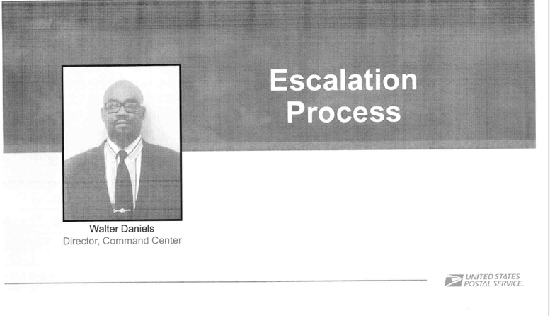

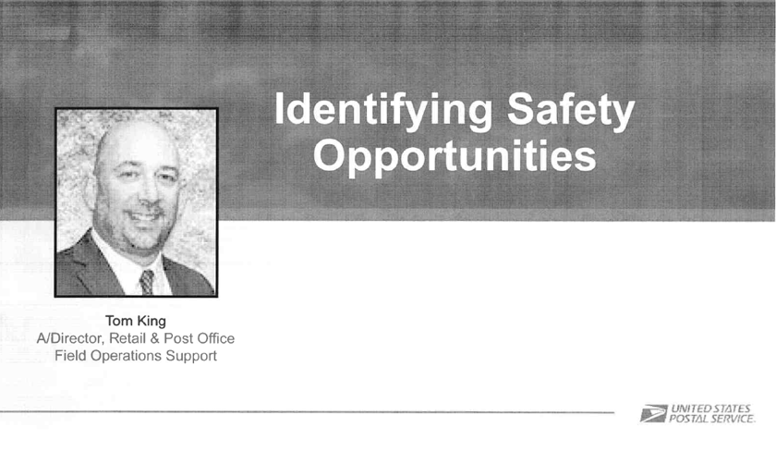

As shown above, if a POD manager is alleged to have observed one of the noted situations, it triggers a required response. Specifically, the POD will immediately stop the employee, ask them to shut off vehicle, remove the key from ignition and wait for further instruction, contact the local supervisor to report to the location. Thereafter, the immediate supervisor must follow instructions and verbally notify the employee they are being emergency placed, drive the employee back to the office, and issue the Emergency Placement Letter from labor. Again, this is the textbook definition of a command decision and “blanket discipline”, i.e., emergency suspension, and is in direct violation of Article 15 and 16 of the National Agreement. The blanket policy does not permit local management to deviate from this instruction. In conclusion, the grievant’s immediate supervisor exercised no independent judgement, rather she emergency placed and signed the disciplinary notice because she was following instructions.

1. JCAM page 15-3 reads in part:

*During the Informal Step A discussion the supervisor and the steward (unless the grievant represents themself) have the authority to resolve the grievance. Both parties must use the JCAM as their guide to the contract. A resolution at this informal stage does not establish a precedent. While either representative may consult with higher levels of management or the union on an issue in dispute, this section establishes that the parties to the initial discussion of a grievance retain independent authority to settle the dispute*

1. At Informal Step A the supervisor and steward meet and both parties must retain independent authority to settle the dispute. Although immediate supervisors may seek advice and/or guidance from higher management, the immediate supervisor must act independently and cannot surrender that independence to the higher manager. Here, the immediate supervisor does not possess the authority to overrule the orders from headquarters to emergency place the grievant, thus they do not have the authority to settle the dispute.
2. The grievant enjoys certain due process rights which are an integral part of just cause. When violations are flagrant and result in a denial of an employee’s due process, then the procedural error must bar any consideration of the fact circumstances. In this matter, the procedural violations, (i.e., discipline was ordered from higher level, and the immediate supervisor did not possess the authority to settle), were egregious and constitute a fatal flaw that cannot be cured.
3. Also, the manner in which the allegations were identified and evidence collected conflicts with Handbook M-39, Sections 134.21 and 134.22, which read:

*134.2* ***Techniques***

*134.21 The manager must maintain an objective attitude in conducting street supervision and discharge this duty in an open and above board manner.*

*134.22 The manager is not to spy or use other covert techniques. Any employee infractions are to be handled in accordance with the section in the current National Agreement that deal with these problems.*

1. In this dispute, management used covert techniques, i.e., followed the grievant in an unmarked car and secretly observed the grievant on the street. This technique is not in an above-board manner and is in violation of Handbook M-39. The union contends any evidence obtained from these covert actions falls under the doctrine of “fruit of the poisonous tree”. Therefore, management is estopped from using this evidence in the grievance procedure.

**MERITS**

1. First, none of the criteria set forth in Article 16, Section 7 of the National Agreement was present on **[date]** with respect to this case. Therefore, there was no legitimate basis to invoke Article 16, Section 7 on the day in question.
2. The language is unequivocal that these placements be made for one of the identified reasons listed. As indicated by the word “emergency”, not only must one of the reasons be present, but management must also show the actions rise to the level of emergency necessary to placing the grievant off-the-clock. However, in the instant case, management has failed to meet their burden to show an emergency existed.
3. The agency violated Article 16.7 of the National Agreement by failing to immediately place the grievant on Emergency Placement as required by Article 16.7.
4. The National Agreement does not contain any clause permitting a delay. The language is unambiguous that these placements be made immediately.
5. Arbitrator Mittenthal plainly wrote — in case H4N-3U-C 58637 — the action is one that occurs instantly, without any lapse in time. Arbitrator Mittenthal further made it clear, when the emergency procedure is properly invoked, the employee suffers an immediate loss of pay. Likewise, the drafters of the National Agreement also plainly wrote, for the emergency procedures — listed in Section 16.7 — to be properly applied, the employee must be immediately placed in a non-pay status.

As indicated in the word “emergency”, this procedure is an acknowledgement by the parties of the potential for a situation to arise where management is compelled to immediately act, to eliminate immediate hazards; where situations pose potential dangers and risks, where time-exhaustive investigations are not feasible. The union, in the grievance at bar, supported by the record of evidence, has proven management did not act immediately.

1. The parties agree the controlling document in an Emergency Suspension case is the Written Notice. The Notice at bar informs the grievant that there are "allegations” they [**INSERT CRITERIA IN 16.7 MANAGEMENT RELIED UPON**]. However, it does not tell the "who", “what”, “when”, “where”, and “whys”.
2. National Arbitrator Mittenthal, in case H4N-3U-C 58637, discussed the written notice requirement under Article 16.7:

*The fact that no "advance written notice" is required does not mean that Management has no notice obligation whatever. The employee suspended pursuant to Section 7 has a right to grieve his suspension. He cannot effectively grieve unless he is formally made aware of the charge against him, the reason why Management has invoked Section 7. He surely is entitled to such notice within a reasonable period of time following the date of his displacement. To deny him such notice is to deny him his right under the grievance procedure to mount a credible challenge against Management ' s action. Indeed, Section 7 speaks of the employee remaining on non -duty, nonpay status "until disposition of the case has been had." That " disposition" could hardly be possible without formal notice to the employee so that he has an opportunity to tell Management his side of the story.* ***Fundamental fairness requires no less.***

1. Even though no advance written notice is required when emergency procedures are invoked, the employee is entitled to a “formal” notice, within a reasonable period of time following the displacement. Here, management did not provide written notice within a reasonable period of time, thus violating Article 16.7.

Clearly, to serve as “formal” notice, it must contain sufficient information to allow an employee to properly defend themselves in the grievance procedure. As stated above, Arbitrator Mittenthal wrote “Fundamental fairness requires no less”. Here, the notice is overly vague.

The union advances this denied the grievant an opportunity to mount a credible challenge against this adverse action. The notice does not charge the grievant with violating any specific rules or regulations, whereas the grievant is entitled to be formally comprised of the charges against them.

Without being advised of the precise facts leading up to the discipline, how can an employee be expected to defend themselves?

1. Article 16 of the National Agreement states in relevant part:

*“In the administration of this article, a basic principle shall be that discipline should be corrective in nature, rather than punitive. No employee may be disciplined except for just cause…”*

1. The test management must satisfy rests upon how the “emergency” action is categorized. If action is taken for alleged misconduct, as is the case here, then management is subject to the just cause” test. Accordingly, the National Agreement demands management have just cause when placing an employee in an off-duty status pursuant to Article 16.7.
2. Article 16 demands management articulate — through the production of evidence, their burden of proof in relation to just cause.

JCAM page 16-3 relays in part:

***Examples of Behavior.*** *Article 16.1 states several examples of misconduct which may constitute just cause for discipline. Some managers have mistakenly believed that because these behaviors are specifically listed in the contract, any discipline of employees for such behaviors is automatically for just cause. The parties agree these behaviors are intended as examples only.* ***Management must still meet the requisite burden of proof, e.g., prove that the behavior took place, that it was intentional,*** *that the degree of discipline imposed was corrective rather than punitive, and so forth. Principles of just cause apply to these specific examples of misconduct as well as to any other conduct for which management issues discipline.* [Emphasis added]

1. As stated, in disciplinary matters management must carry their burden of proof, prove the alleged behavior occurred, that it was intentional, and that all the caveats of just cause were satisfied. The just cause principle presupposes management to provide fair and provable reasoning for discipline. The union does not bear a commensurate burden — this burden strictly falls on management. In the instant case, the file is devoid evidence to support the Emergency Placement was taken for just cause.
2. Regardless of how this situation is viewed, the inescapable conclusion is that management failed to follow Section 115 of the M-39 Handbook. Section 115.1 of the M-39 Handbook states:

*“In the administration of discipline, a basic principle must be that discipline should be corrective in nature, rather than punitive. No employee may be disciplined or discharged except for just cause.* ***The delivery manager must make every effort to correct a situation before resorting to disciplinary measures.****”*

*[Emphasis added]*

1. Management did not pass the *any effort* test, much less the *every effort* test to correct this situation prior to resorting to discipline in this case.
2. Management failed to obtain proper review and concurrence. The same principle that governs the advance notice requirement in emergency situations also governs the application of the article 16.8 concurrence requirement. Although it may not always be possible to obtain concurrence before emergency action is taken, it still must be obtained.
3. To conclude, the union contends the emergency procedure, under Article 16.7, was not invoked immediately as prescribed. Similarly, the union maintains the written notice did not comport with the requirements outlined in the NA. In addition, the grievant’s due process rights were eviscerated by management. Based on the foregoing facts, contentions, and analysis of the evidence, the undeniable conclusion is management improperly invoked the emergency procedure in this case.

**Remedy (Block 19 of PS Form 8190):**

1. That the notice of Emergency Placement in Off Duty Status dated **[date]** and issued to Letter Carrier **[name]** for “**[charge]**” be withdrawn and removed from all employee records and files effective immediately.
2. That Letter Carrier **[name]** be made whole for all lost wages and benefits lost as a result of this action to include the average number of overtime hours worked by other Letter Carriers on the 12-hour ODL, or whatever remedy the Step B team or an arbitrator deems appropriate.

**National Association of Letter Carriers**

**Request for Information**

To: ________________________ Date ___________________

(Manager/Supervisor)

_________________________________

(Station/Post Office)

Manager/Supervisor _______________________,

Pursuant to Articles 17 and 31 of the National Agreement, I am requesting the following information to investigate a grievance concerning a violation of Articles 16, 19 and 29:

1. Copy of Letter Carrier **[name]**’s TACS Everything Report for **[date(s)]**.
2. PS Forms 4584
3. Escalation emails from the POD on this issue
4. Any and all correspondence with the POD Team Lead with the POD employee or local management on this issue

I am also requesting copies of any and all documents, statements, records, reports, audio/video tapes, photographs, or other information learned, obtained, developed or relied upon by the Postal Service in the issuance of the Emergency Placement dated **[date]**, involving employee **[name]**.

I am also requesting time to interview the following individuals:

1. **[Name]**
2. **[Name]**
3. **[Name]**

Your cooperation in this matter will be greatly appreciated. If you have any questions concerning this request, or if I may be of assistance to you in some other way, please feel free to contact me.

Sincerely,

_________________________ Request received by: _____________________

Shop Steward

NALC Date: ___________________



**National Association of Letter Carriers**

**Request for Steward Time**

To: ____________________________________ Date ___________________

(Manager/Supervisor)

____________________________

(Station/Post Office)

Manager/Supervisor _______________________,

Pursuant to Article 17 of the National Agreement, I am requesting the following steward time to investigate a grievance. I anticipate needing approximately _______________ (hours/minutes) of steward time, which needs to be scheduled no later than ________________ in order to ensure the timelines established in Article 15 are met. In the event more steward time is needed, I will inform you as soon as possible.

Your cooperation in this matter will be greatly appreciated. If you have any questions concerning this request, or if I may be of assistance to you in some other way, please feel free to contact me.

Sincerely,

__________________________ Request received by: _________________________

Shop Steward

NALC Date: ___________________